Sukanta Sen
OBJECTIVE
An accomplished, Datawarehousing related ETL development and testing oriented Software Professional with over 5 Years ’ experience in Tata Consultancy Services Ltd – Kolkata , specializing in PL/SQL and Unix ETL development , ETL Testing, Data Warehousing . I have end to end knowledge for data warehouse development .I am Passionate to pursue a rewarding career in IT-industry by contributing to the organizational goals & enhancing own skill sets.
ACADEMIC QUALIFICATIONS
Institute | Degree | Scores | Year
Rajabazar Science College(Affiliated to Calcutta University) | MCA | 74. 82 | 2011
Kandi Raj College(Affiliated to University of Kalyani) | BSC Math(H) | 60.13% | 2008
Kandi Raj High School(WBCHSE) | H.S (XII)  ) | 70.6% | 2004
Kandi Raj High School(WBBSE) | Secondary(X) | 78.8 | 2002
WORK EXPERIENCE
Project | BT OPENREACH
Client | British Telecommunication. UK.
Project Name | Openreach Business Intelligence Team (ORBIT)
Current Role | ETL Testing
Current Designation in TCS | IT Analyst (ITA)
Project Description | Open reach Business Intelligence Team (ORBIT) ORBIT is a Data warehouse build for crating analysis on order, fault, asset, task, Engineer data for British Telecommunication (Open reach).  ORBIT as a Data warehouse which receives feeds(Batch data/Real-time data ) from different source systems, and after Design and ETL development ,different Measures are generated (Output shown in OBI reports/Oracle Apex Reports)which helps open reach business to take necessary actions for improving their business.
Duration in Offshore (BT OPENREACH) | Dec 2011 - Jul 2016
Team size | 40-60

Technical Knowledge (Tools and Technology used)
- QC (HP Quality Center).
- Oracle –Pl/Sql (9i,10g,11g)
- Toad-for writing codes
- Oracle Warehouse builder (Version 10g,11gR1,11gR2)
- Oracle - Apex (version 4.0,5.0)
- Linux Shell Scripting
- Unix Scripting
- Informatica (Basic level).
- Hue(Pig ,Hive) for Hadoop Big data system.

Technical Skills and Work Description/Roles and Responsibilities Performed
  - Hands on experience on different stages/Schema of Data warehouse such as
DRA(Data reception area ),DSA (Data Staging Area), ODW(Oracle Data Warehouse Area)
  - Hands on experience on providing Complete End to end Development in Data Extract , Data
Transform, Data Load , Import Source, Import Target ,Workflow,Worklets,
  - Hands on Experience on PL/SQL different queries ,Functions, Joining ,Index, Partitions for data warehousing.
  - Hands on experience type of Schema like Star Schema, Snowflake, Galaxy etc for ETL development.
  - Hands on experience on Hands on experience on Mappings, Maplets, Transformations, Funtionalities, Rules and Techniques.
  - Work experience on OLTP, OLAP,ROLAP,MOLAP ,Initial Load, Full Load, and Incremental Load.
  - Hands on experience Dimension Normalization, Views, Materialized Views, Constraints, Data Types.

  - Hands on experience on Oracle Warehouse builder (OWB Map development for extract transform and load).
  - Hands on experience on performance tuning. (Partitioning ,Indexing,Parralel,Bulk Collection )
  - Hands on Experience on development of Oracle Packages, Procedures, functions, sequence, trigger , AQueue and DQueue etc.
  - Leads Big Migration Project (Oracle10g to Oracle11g) and from Unix Platform to Linux from Development/Testing perspective
  - Hands on Experience on VDC Migration Project (Old Unix server to Linux Server Migration ) and Oracle10g to Oracle11g Development/Testing perspective.
  - Knowlegde on Testplan, Test Case preparation ,Test case Execution.
  - Hands on Experience on Unit Testing ,White Box Testing, Regression Testing,CST Testing, IVVT Testing, UAT .
  - Initial work experience on Bigdata,Hadoop with Hive and Pig.
- Roles and responsibilities as a oracle PL/SQL developer
Please find details of some projects on which I have worked as ETL and data warehouse developer.
- View My Job (VMJ) MIS :-VMJ is a BT Product Specially develop for Customer Provider like BT, Vodaphone who can easily able to track the ORDER and can get to know the whole order journey details in real time system.
When BT Launched VMJ application as a real time strategic product, there was a huge requirement for creating MIS reports for measuring Engineering activities and proper utilization of different Task allocated to Different Engineer.
Ask is also to produce different type of feed file in format .dat..txt, .gz using Shell script in Unix.
- Engineer Perfromance (Skill and Measure) Project :-Previously there was no specific guidance and supporting information provided to field engineers of BT, on how to handle different skills and tasks efficiently in the allocated time frame as there is no service layer (line health) data available to band the job and allocate to the correct skilled engineer with a specified task time. This is causing ineffective utilization of engineering resources and their time to handle the same jobs within the same task duration; which could have been resolved in less.
As part of this project ORBIT System started receiving Engineer Performance for each and every engineer work in the field from a BIG Data platform MAL and ESB via AQ and DQ Mechanism.
And Main ask of this project is
- ORBIT have to create an transactional real time service by which ORBIT can support data request for Engineer information coming from Iphone Application to MAL (Source system) via ESB. this data service is done via Request and Response xml through AQueue and DQueue features in Oracle system.
- ORBIT have to create an report, which will give visualization on Iphone Application based on different measure and skill with respect to date Dimension
- ORBIT will provide below views to user
Summary – Drill View
Graph- view
Map Viewer view
- Agile (Rapid Deliveries)As part of a rapid Delivery Program, where Design ,Development and Testing time line is much smaller than normal delivery ORBIT have to Design ,Development and build Some reports on Engineer Allocation ,Customer, Demand etc. on orders and Faults
- Some Award Details
Title | Category | Sub-Category | Recived On
Best Team | Awards for Excellence | Star Awards | 28/03/2015
Star Team | Awards for Excellence | Star Awards | 08/04/2014
On The Spot Award | Awards for Excellence | On The Spot Awards | 04/04/2013
- .
- Customer Appreciations

Below are some customer Appreciations, which I received in my career.
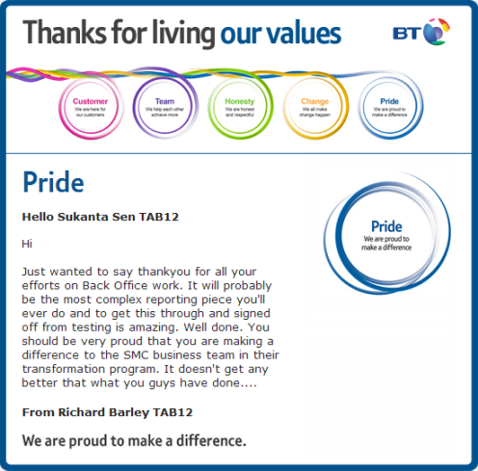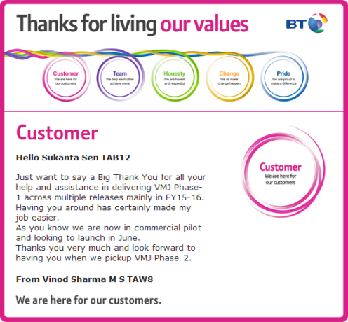
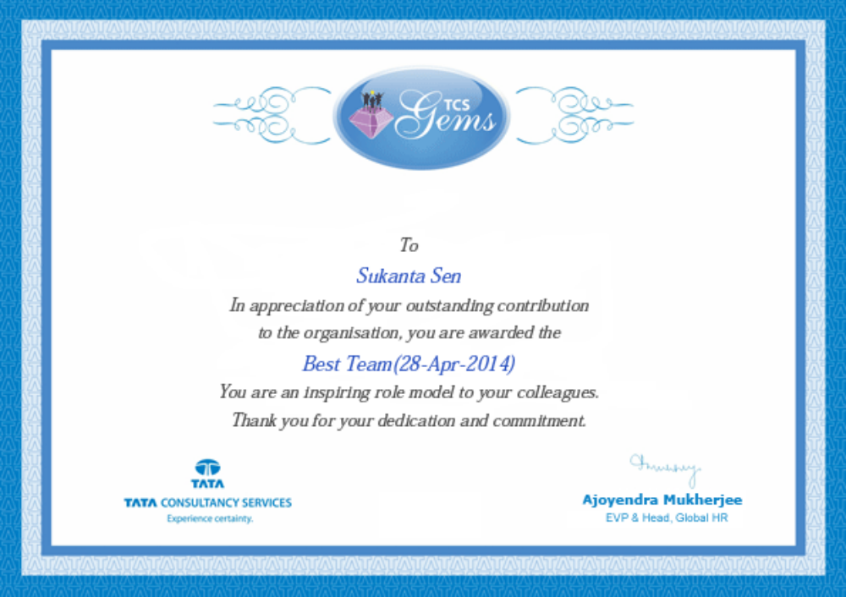

- Personal Communication Details
Email id: - Sukanta.sen2008@gmail.com
Alternative –sukanta.sen@bt.com
Mobile Number: 9432856413/9831257596
Permananet Address:-Kandi,Boltala,Jibdharpara
Dist-Murshidabad
PIN-742137
DOB-10-OCT-1985

